

Final Project

Sukkur IBA University Kandhkot Campus Online Registration Form



July 8, 2021

Sukkur IBA University Camous kandhkot

Near Clock Tower Kandhkot

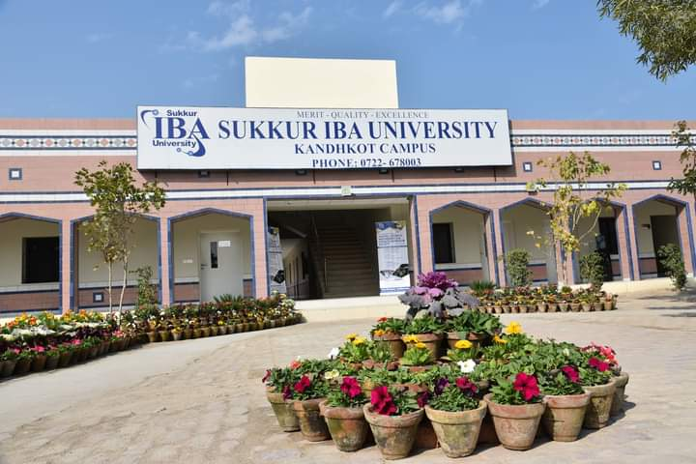

Sukkur IBA University Kandhkot Campus

Final Project Report On SIBAU Online Form Submission.

**Designed By: -** Dilbar Hussain **Instructor: -** Syed Muzamil Hussain Shah

**Final Project On Sukkur IBA University Kandhkot Campus Online Submission Form**

1. **Aims of the Project:**

* This Project is designed to fill online form of any university but we designed it through the policies of the Sukkur IBA University Kandhkot Campus.
* This Project is designed easy to fill. Many Advantages of this project, this will also tell the student what you have to done in next.
* This project is designed in auto system, many function has kept in this project which follow the rules of any university.
* This Project will take whole data regarding personal and educational details.

1. **Objectives and Learning Outcomes:**

* At the end of this project student should:
* Be able to know the concepts of object-oriented programming in java.
* Be able how to make methods, functions and how to override methods or functions.
* Be able to know how to fill form easily and this project is designed on the basis of gaining knowledge of the object-oriented programming in java.
* In this project file handling also have used to show all details in a way and also save that details for the next.
* File handling is an easy process of saving details and we can access them after until we put another data.
* In this project three methods have made one by one they will execute and will take details from us and in last they will display on the console screen, and this project also save all details which we input in this project.
* I wished for this project there is reason behind this which is in Skills.com phase 2.0 we have registered many boys but at the day of test we face many difficulties to check the detail of each boy is this enrolled or not after that program I think that I will make a project which helps us in enroll and check details on the day of program is this enroll or not. I make this project on an auto system.
* This huge project will help all learners to get basic knowledge of the object-oriented programming in java.

1. **Introduction of the project:**

* This project has designed on the Sukkur IBA University Kandhkot Campus online form submission. Through this project we can fill online of any university but this project especially designed for the SIBAU Kandhkot Campus.
* This project also designed for the learning. Any one after practicing this project will make your self-project and gain more concepts of object-oriented programming in java.
* In this project at least four methods have designed to give desired results related to the project.
* In this project the four methods we use are step by step defined here.
* In First method we write whole code related to the bio-data of the student regarding name, father name, email id, number and address of the student. The code has written well in good way any one can easily learn and also develop yourself same type of project for any organization or any company, or university.
* In Second method we write whole code related to the educational details in which student’s matric and inter marks and student’s percentage and in this I have used if check in which I have defined many things related to the university rules and some other data. In which method one thing I have used clearly that if any student percentage of the matric or inter is less than 50% then he will not eligible for the university test. When full details will complete then one line will print the data that step towards the next phase, this phase has completed successfully.
* In Third method we keep some options related to the university departments and also use if statements that 1 press for the Computer Science department, and 2 for the Software engineering, and 3 for the Bachelor of Electrical engineering, and 4 for the Bachelor of Education department, and 5 for the bachelor of Business Administration, and If we don’t want to enroll then we press 6 the program execution will stop at this point.
* The Fourth and last one in this I have displayed all the details which I have got from user, the whole data will displayed here and in last print on line that your form has submitted successfully.

1. **Conclusion:-**

* The Project Sukkur IBA University Kandhkot Campus Online Form Submission is designed especially for the SIBAU Kandhkot Campus this will be used in many programs from submission. This small project is designed and behind this one reason which is that when small programs held in this campus we face many difficulties to fill form and manage records and also on the day of program we have to check the names of the boys which are enrolled so more waste of time. This project take details save that details and also at any time we want to check this will show all results.
* In this project all things are separated by methods, each one has its own method. At least four methods have done in all these different functions have been performing. As in method one we give on student’s bio-data related to them. In which some data like mail id, address and number. In Second technique we compose entire code identified with the instructive subtleties wherein understudy's matric and entomb imprints and understudy's rate and in this I have utilized if check in which I have characterized numerous things identified with the college rules and some other information. In which technique one thing I have utilized plainly that if any understudy level of the matric or entomb is under half then he won't qualified for the college test. At the point when full subtleties will finish then one line will print the information that progression towards the following stage, this stage has finished effectively. In Third strategy we keep a few alternatives identified with the furthermore use if explanations that 1 press for the Computer Science, and 2 for the Software Engineering, and 3 for Electrical engineering, and 4 for then Bachelor of Education department, and 5 for the Business Admiration, and Assuming we would prefer not to enlist, we press 6 the program execution will stop now.
* This project will help all the new learners to gain the concepts of object-oriented programming in java. After studying this project any one can create a valuable project. This project is designed in this way that this project will guide you that what you have to do next. In this project I try to use simple things and make easy way to learn. In this project all different things are separate from each other by the methods each method have called on its suitable time. Actually, this project will help all the new learners because many concepts of the object-oriented programming in java have used with easy way to learn.